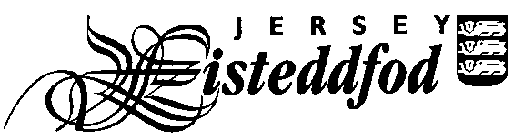
ENTRY FORM – SECTION DU JÈRRIAIS
For official use only
Competitor No.
ADULT PAIR / GROUP ENTRIES

Entries close Friday 8th December 2023

PLEASE COMPLETE ONE FORM PER GROUP ENTRY. PLEASE USE BLOCK CAPITALS.

Title of piece: ___________________________________________________________________________

Class No: _____________

Please complete the table below to provide the full names of each person in the group.

There is an entry fee of £2 per pair / group.

Please tick to indicate all participants in this group give permission for photographs to appear in the local media
Please tick to confirm all participants in this group have read the Festival Rules *

Please tick to confirm all participants in this group have read the Jersey Eisteddfod Privacy Statement *

Signature: _____________________________________________________

Contact telephone number: _______________________________________

Contact email address: ____________________________________________________________________

Please return this form with the entry fee to the Jèrriais Teaching Service, Children, Young People, Education and Skills, Highlands Campus, PO Box 142, St Saviour, Jersey, JE4 8QJ.
Please make all cheques payable to ‘The Jersey Eisteddfod’.
You can also return the form electronically to Ben Spink via email b.spink@jeron.je

If you have chosen to enter an ‘own choice’ class please ensure you enclose a copy of the piece you have chosen to perform for the Adjudicator.

* You can find the Jersey Eisteddfod Privacy Statement and Festival Rules on the Jersey Eisteddfod website www.jerseyeisteddfod.org.je. If you do not have access to the internet you can obtain a paper copy from the Jèrriais Teaching Service.

