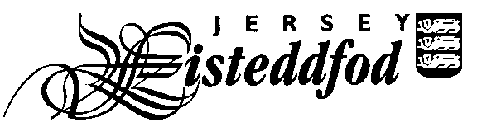
ENTRY FORM – SECTION DU JÈRRIAIS
For official use only
Competitor No.
ADULT INDIVIDUAL ENTRIES

Entries close Friday 8th December 2023

PLEASE USE BLOCK CAPITALS

Full Name of Competitor: _________________________________________________________________

Please complete the table below indicating which class numbers you are entering as an individual and the pieces you are performing. More information can be found on www.learnjerriais.org.je

There is an entry fee of £2 for each individual entry.

Class No | Title of Piece | Entry Fee
Total Fee
Please tick to give permission for photographs to appear in the local media

Please tick to confirm you have read the Festival Rules *

Please tick to confirm you have read the Jersey Eisteddfod Privacy Statement *

Signature: _____________________________________________________

Contact telephone number: _______________________________________

Contact email address: ____________________________________________________________________

Please return this form with the entry fee to the Jèrriais Teaching Service, Children, Young People, Education and Skills, Highlands Campus, PO Box 142, St Saviour, Jersey, JE4 8QJ. Please make all cheques payable to ‘The Jersey Eisteddfod’.
You can also return the form electronically to Ben Spink via email b.spink@jeron.je

If you have chosen to enter an ‘own choice’ class please ensure you enclose a copy of the piece you have chosen to perform for the Adjudicator.

* You can find the Jersey Eisteddfod Privacy Statement and Festival Rules on the Jersey Eisteddfod website www.jerseyeisteddfod.org.je. If you do not have access to the internet you can obtain a paper copy from the Jèrriais Teaching Service.

